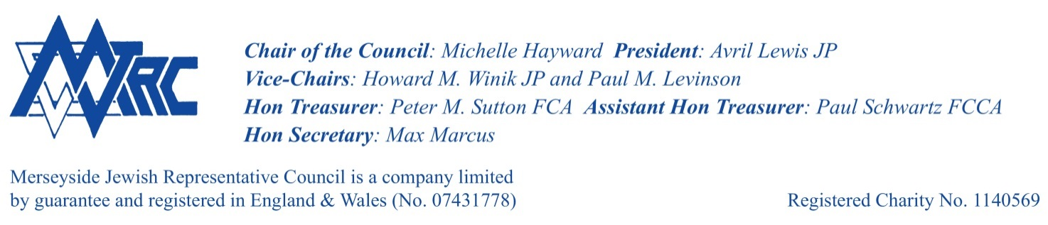**Supplementary Notice 1 MJRC AGM**

**This notice supports the following agenda items**

**(ii) Election of MJRC Board of Deputies Representative**

Board of Deputies Election 2024

The Board of Deputies of British Jews is the voice of the British Jewish community. They are democratic and cross-communal, and their Deputies play an invaluable role in their overall work. During COVID 19 they worked had to ensure that Jewish funeral rites were able to be observed and Over the last few weeks, we have seen how vital the role that the Board of Deputies plays is.

Merseyside Jewish Representative Council, is entitled to elect 1 Deputy for the forthcoming Triennial Session along with 1 under 35’s observer which begins in June 2024.

All voting members of MJRC are entitled to stand, if you are unsure of your eligibility please contact us

If you are interested in standing as the deputy on behalf of MJRC please send a short paragraph (max 300 words) to outline why you feel you would like to stand and included what skills, experience and attributes you would bring to the role . Please send this is the Hon Sec [zarahalia@yahoo.co.uk](mailto:zarahalia@yahoo.co.uk) by Friday, 30 March 2024.

A vote will take place on 8th April at the MJRC AGM

For more information on the work of The Board of Deputies of British Jews please visit <https://bod.org.uk/>.



