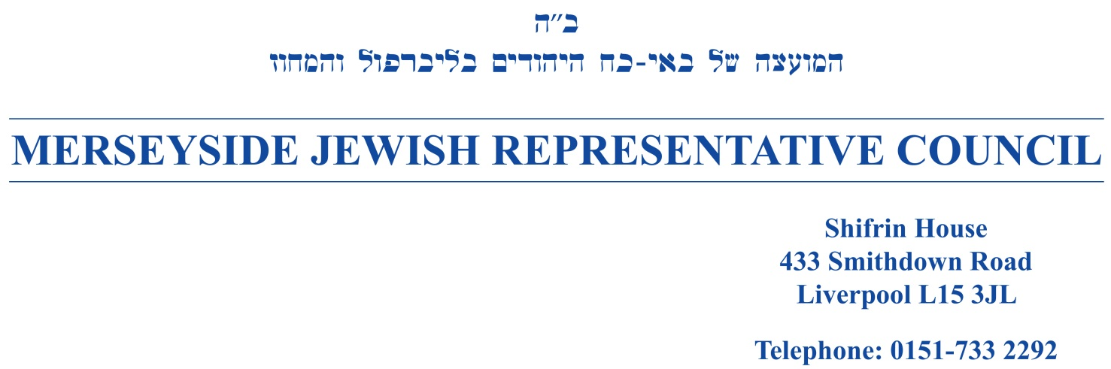

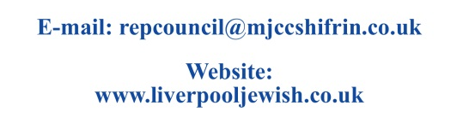
April 2025

Dear Friend

Merseyside Jewish Representative Council
invites you to be an advertiser in our 2025-2026 Year Book.

Merseyside Jewish Representative Council, established in 1944, acts as an umbrella organisation for cohesion representing the Jewish communities of Liverpool, Southport, Wirral and its neighbouring areas. It facilitates the promotion of co-operation and collaboration within the Jewish community, as well as between the community and the statutory authorities. It also facilitates and promotes Jewish educational, cultural and religious activity, in addition, to enhancing interfaith and interethnic understanding and harmony.

Your much needed help and support of the year’s Year Book will make a difference and mean that Merseyside Jewish Representative Council can continue their work in shaping the future and quality of Jewish life. If you are interested, please select the advert size below that is right for your needs.

Full page 5” x 7.5” £180 / Half page 4” x 5” £100 / Quarter page 2.5” x 4” £75

Please kindly return the form to us by 11th July 2025.

Your support of our community is greatly appreciated.

If you have any queries, please contact the Year Book team on 0151-733 2292 or email repcouncil@mjccshifrin.co.uk.

Thank you in anticipation of your support.

Yours sincerely

Paul Levinson
Jeremy Wolfson

Paul Levinson and Jeremy Wolfson
Vice-Chairs, Merseyside Jewish Representative Council
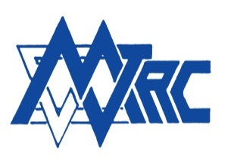
Chair of the Council: Vacant Immediate Past Chair & Hon Officer: Max Marcus
President: Barry Levene Vice President: Michelle Hayward
Vice-Chairs: Paul Levinson and Jeremy Wolfson
Civic Liaison Officer: Michelle Hayward
Hon Treasurer: Howard Simon
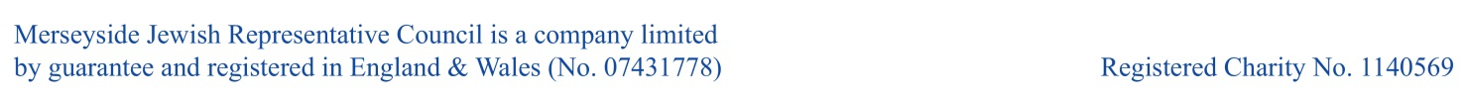
Hon Secretary: Zarah Ross BEM Assistant Hon Secretary: October Wright
MERSEYSIDE JEWISH REPRESENTATIVE COUNCIL


ANNUAL YEAR BOOK

Order form for Brochure advertising

I/We are pleased to be associated with the 2025 MJRC Year Book

Full Page Greeting | 5” x 7.5”  130 mm x 190 mm | £180.00
Half Page Greeting | 4” x 5”  95 mm x 130 mm | £100.00
Quarter Page Greeting | 2.5” x 4”  65 mm x 95 mm | £75.00

Amount Due: £ …………………...……..

Please make cheques payable to: “Merseyside Jewish Representative Council” or BACS credit to: Sort Code 40-29-03, Account No 91578944, Reference “Year Book”

Please choose one of the following (full page, half page or quarter page only):
Use last year’s copy Use attached copy Use the following wording:

………………………………………………………………………….…....

………………………………………………………………………….…....

………………………………………………………………………….…....

Name(s) (to be printed in year book) .....................………………………………………...........

Address (not for publication) …………………………….………………………………….………

...................................................................................………….………………………………….........

Please return form to:
MJRC Year Book, Shifrin House, 433 Smithdown Road, Liverpool, L15 3JL

